EXPT NO: 1 | BUILDING AND TRAINING A SIMPLE ARTIFICIAL NEURAL NETWORK (ANN) FOR REGRESSION AND CLASSIFICATION
DATE: 20/07/26

PRE-LAB QUESTIONS (PROVIDE BRIEF ANSWERS TO THE FOLLOWING QUESTIONS)

- What is an Artificial Neural Network (ANN)?

An Artificial Neural Network (ANN) is a machine learning model inspired by the human brain. It consists of interconnected artificial neurons organized into layers that learn patterns from data to make predictions or classifications.

- What are the functions of the input, hidden, and output layers in an ANN?

Input Layer: Receives the input features and passes them to the hidden layer. It does not perform computations.
Hidden Layer: Processes the input data, learns patterns, and performs computations using weights, biases, and activation functions.
Output Layer: Produces the final prediction or classification based on the processed information.

- Why is feature scaling important before training an ANN?

Feature scaling is the process of bringing all input features to a similar range. It helps the ANN train faster, improves convergence, and prevents features with larger numerical values from dominating the learning process.

- Differentiate between regression and classification problems with examples.

Regression predicts continuous numbers (e.g., forecasting house prices), whereas classification assigns data to discrete categories (e.g., identifying an email as spam or not spam).

- What is the role of the activation function in a neural network?
An activation function determines the output of a neuron and introduces non-linearity into the neural network. It enables the ANN to learn complex patterns and relationships in data. Common activation functions include ReLU for hidden layers and Sigmoid for binary classification.

AIM
To understand the implementation of Artificial Neural Networks (ANN) using TensorFlow and evaluate their performance on regression and classification problems.

SOFTWARE REQUIREMENTS
- Python 3.x
- Google Colab / Jupyter Notebook
- TensorFlow 2.x
- NumPy
- Pandas
- Matplotlib
- Scikit-learn

LEARNING OBJECTIVES
After completing this experiment, students will be able to:
- Understand the architecture of an Artificial Neural Network.
- Build an ANN for regression problems.
- Build an ANN for classification problems.
- Train and evaluate neural network models.
- Compare different evaluation metrics used for regression and classification.

THEORY
An Artificial Neural Network (ANN) is a machine learning model inspired by the human brain. It consists of interconnected neurons organized into layers.
A simple ANN contains:
- Input Layer
- Hidden Layer(s)
- Output Layer
During training, the ANN learns by updating weights using Backpropagation and an optimization algorithm such as Adam Optimizer.

PART A – ANN FOR REGRESSION
DATASET: California Housing Dataset
SOURCE: Scikit-learn
DESCRIPTION
- Samples: 20,640
- Features: 8
- Target: Median House Value

FEATURES
Feature | Description
MedInc | Median Income
HouseAge | House Age
AveRooms | Average Rooms
AveBedrms | Average Bedrooms
Population | Population
AveOccup | Average Occupancy
Latitude | Latitude
Longitude | Longitude

ALGORITHM
- Import libraries.
- Load California Housing dataset.
- Split into training and testing sets.
- Standardize the features.
- Build ANN model.
- Compile the model.
- Train the model.
- Predict house prices.
- Evaluate using:
  - MSE
  - MAE
  - RMSE

TASK A:

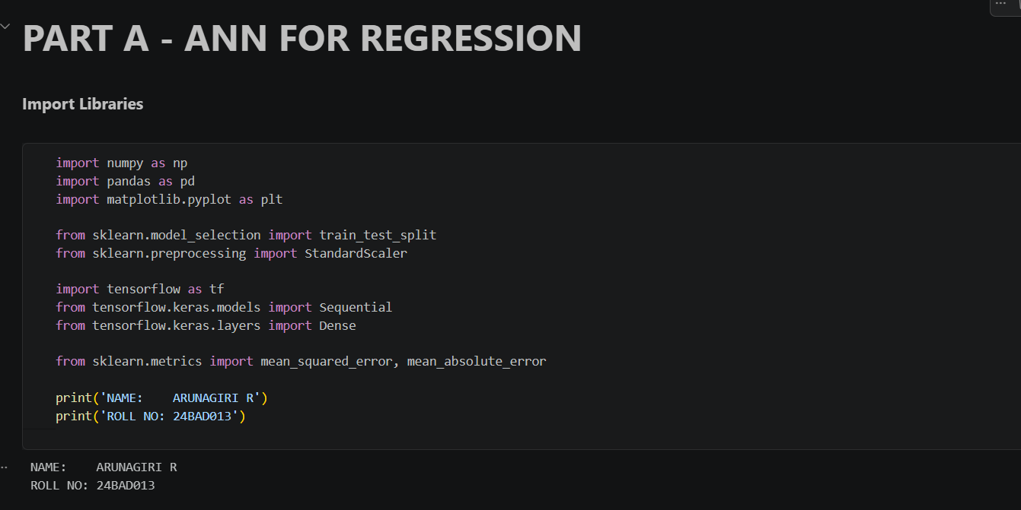

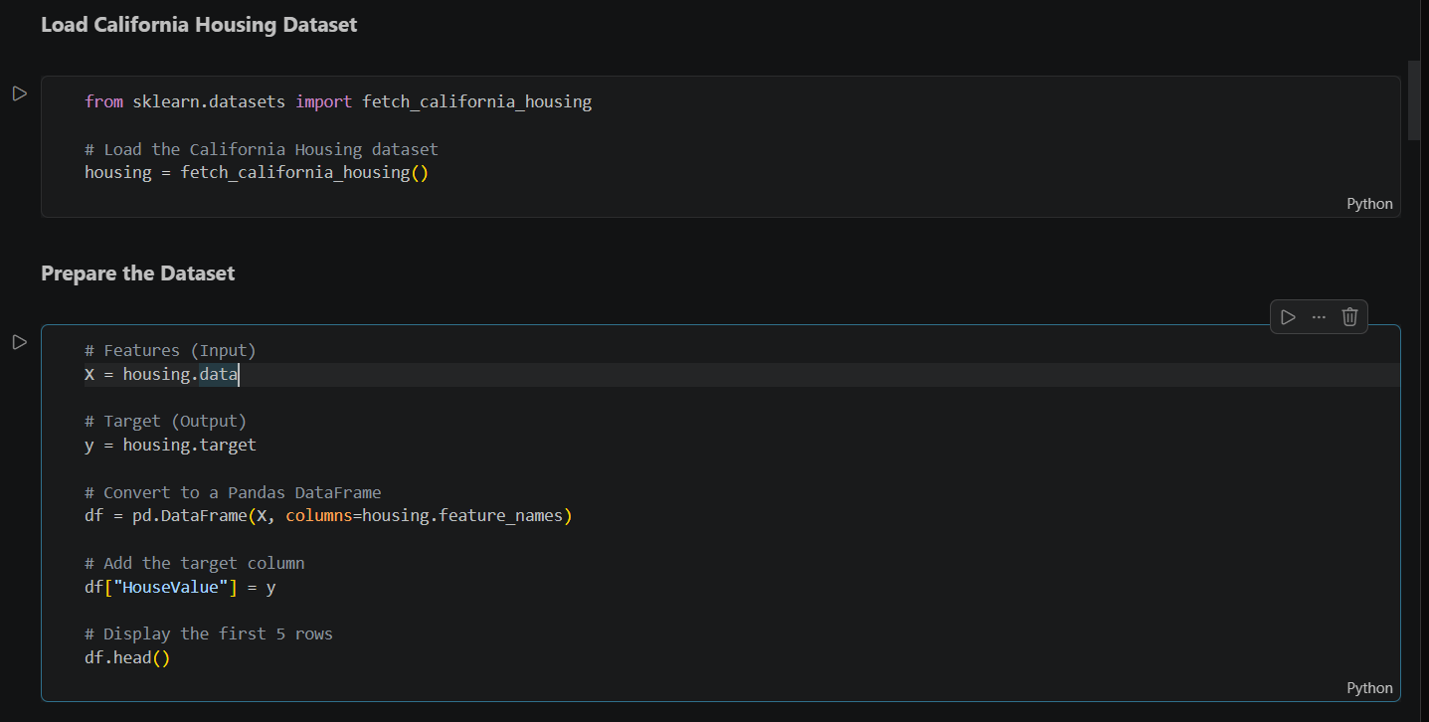

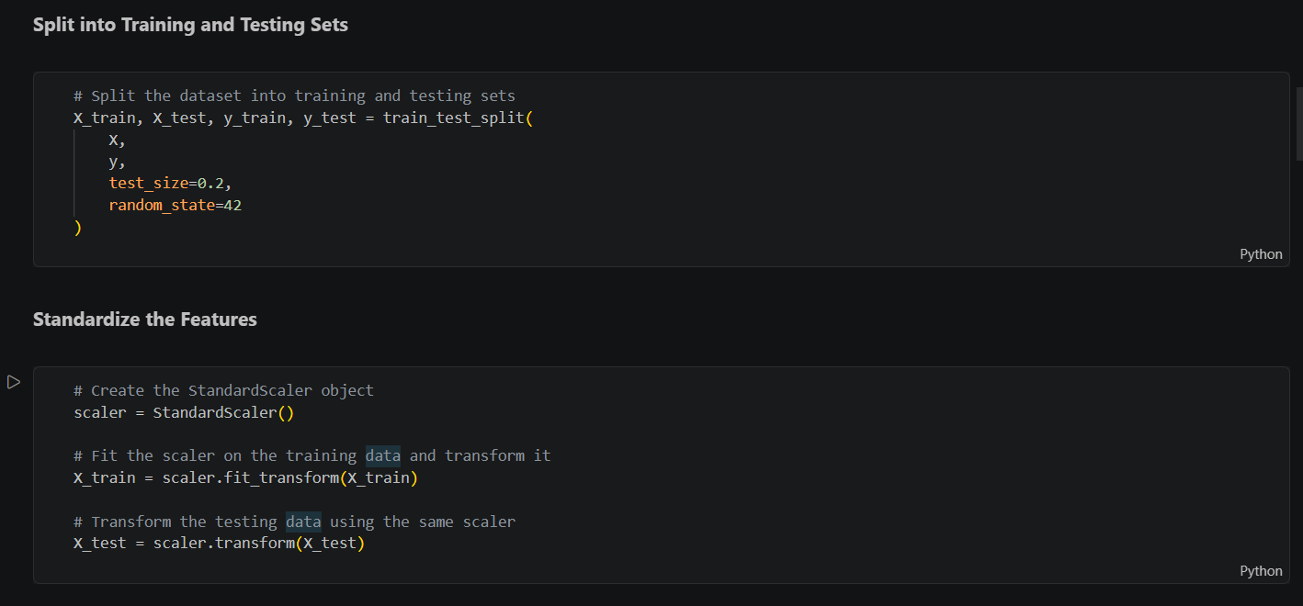

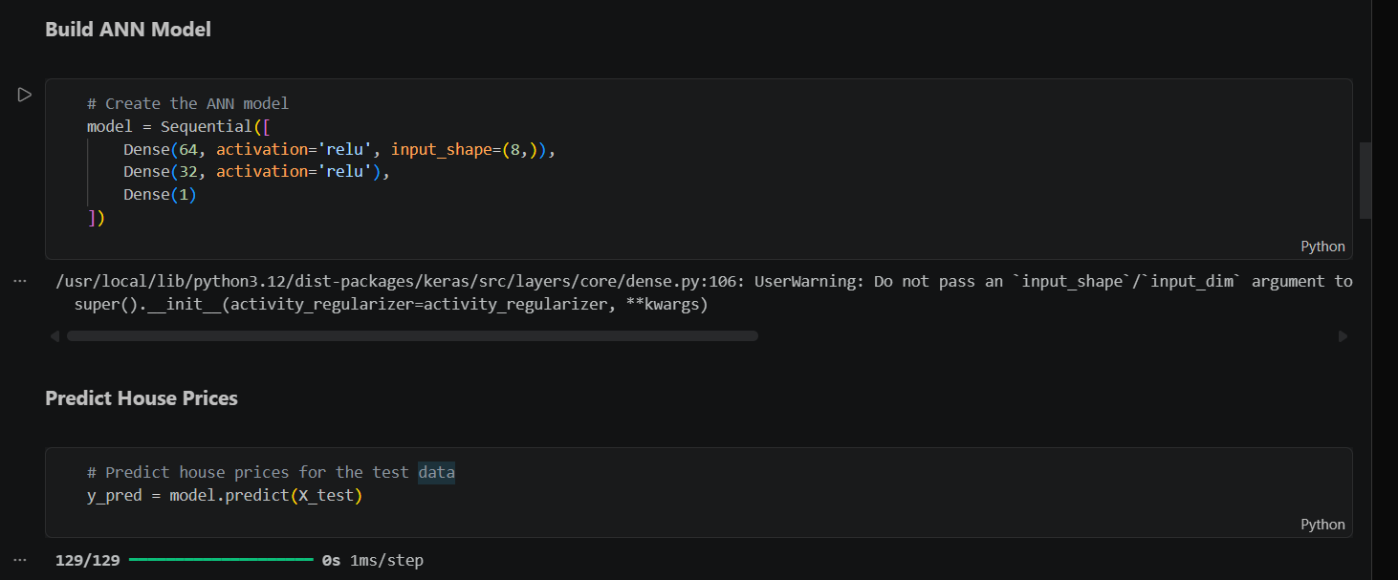

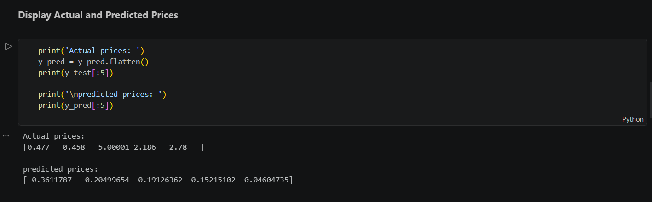

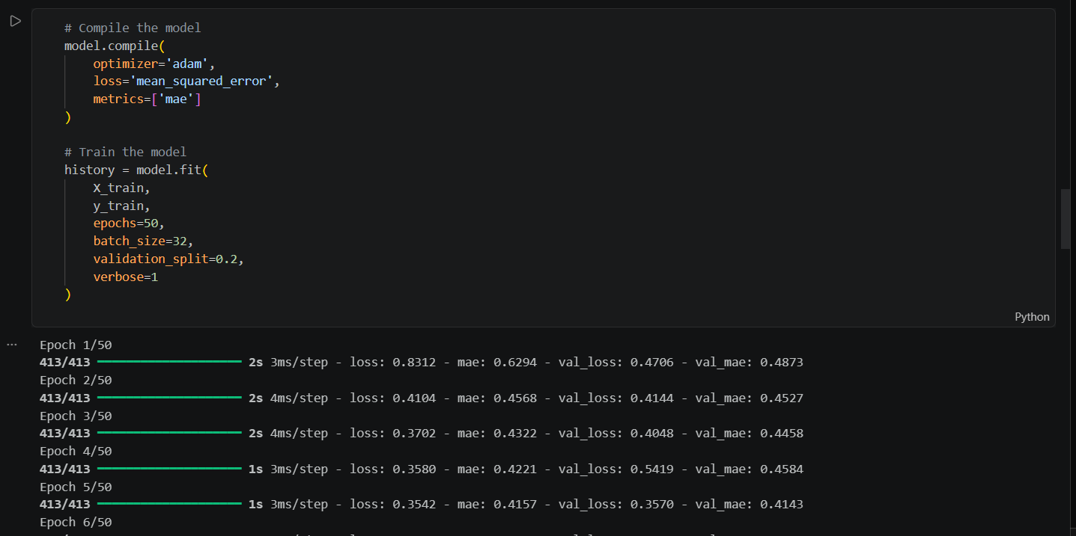

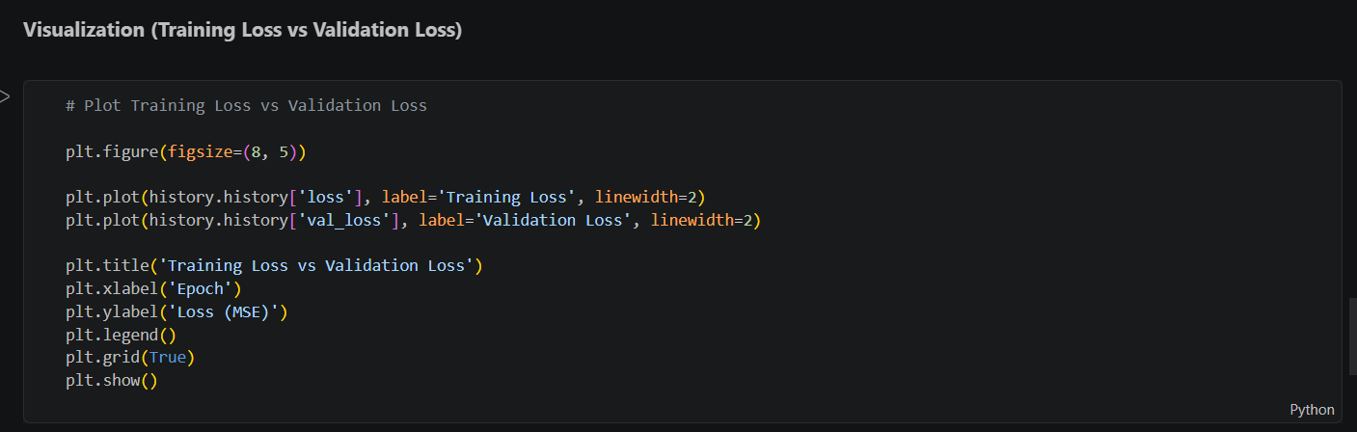
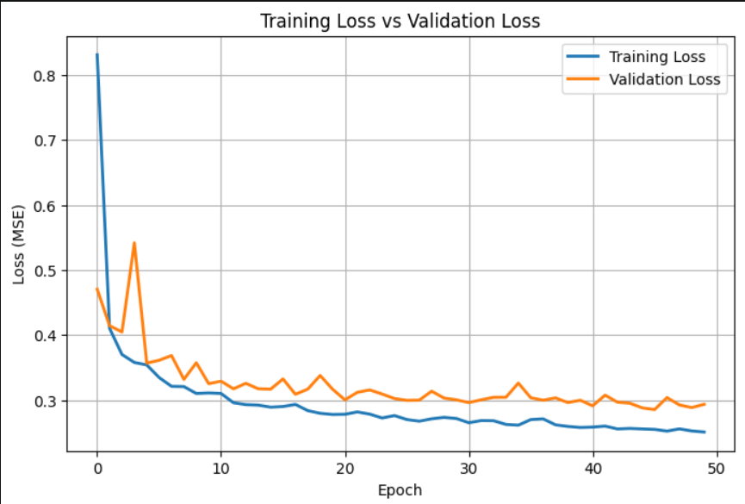
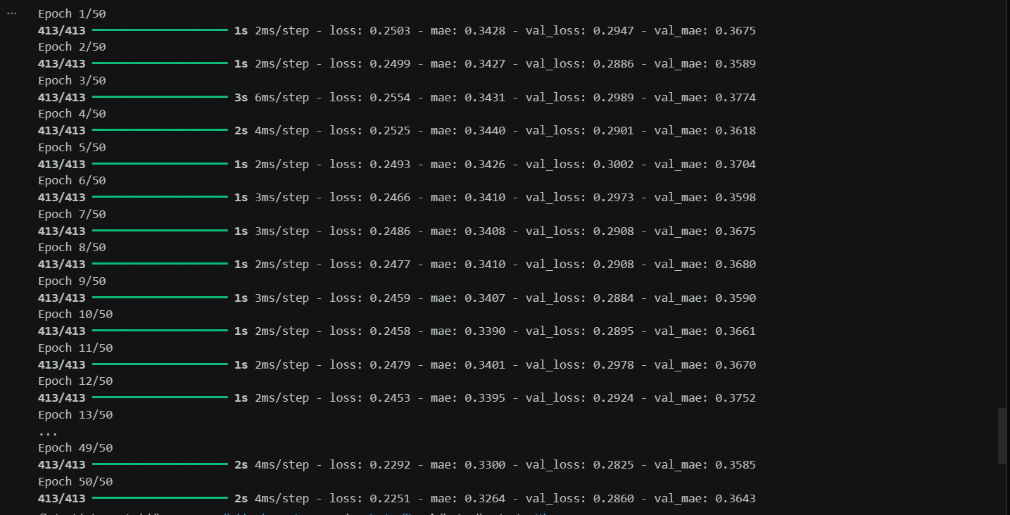

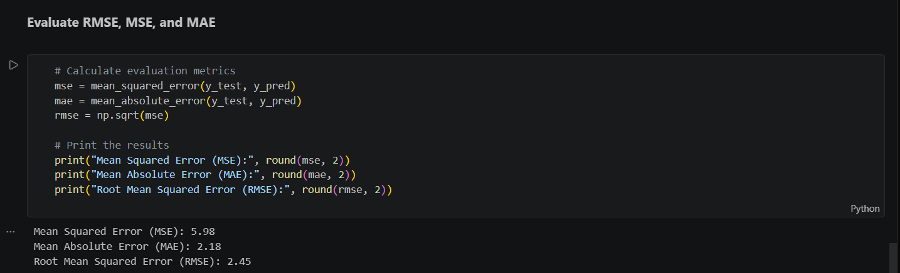

PART B – ANN FOR CLASSIFICATION
DATASET: Breast Cancer Wisconsin Dataset
SOURCE: Scikit-learn
DESCRIPTION
- Samples: 569
- Features: 30
- Classes:
  - Malignant
  - Benign

ALGORITHM
- Import libraries.
- Load Breast Cancer dataset.
- Split dataset.
- Standardize features.
- Design ANN.
- Compile model.
- Train model.
- Predict labels.
- Evaluate:
  - Accuracy
  - Precision
  - Recall
  - F1-score
  - Confusion Matrix

TASK B:

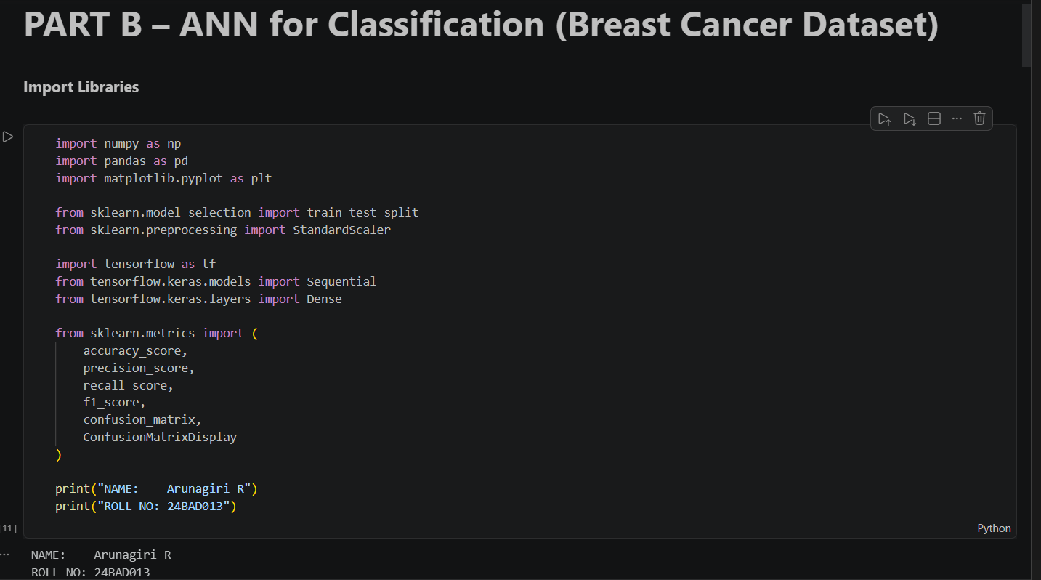

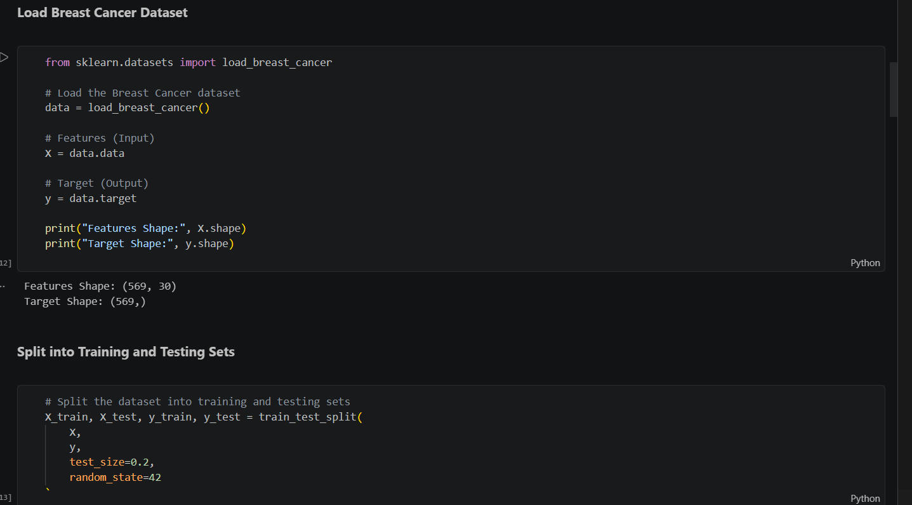

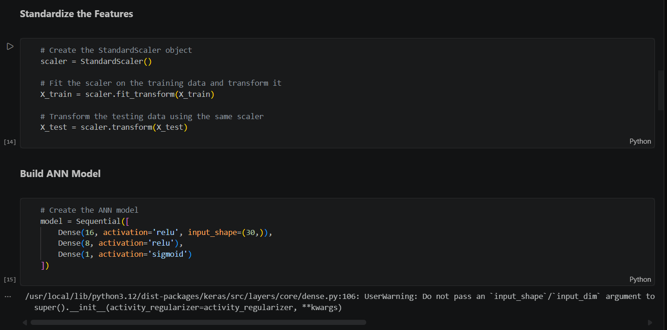

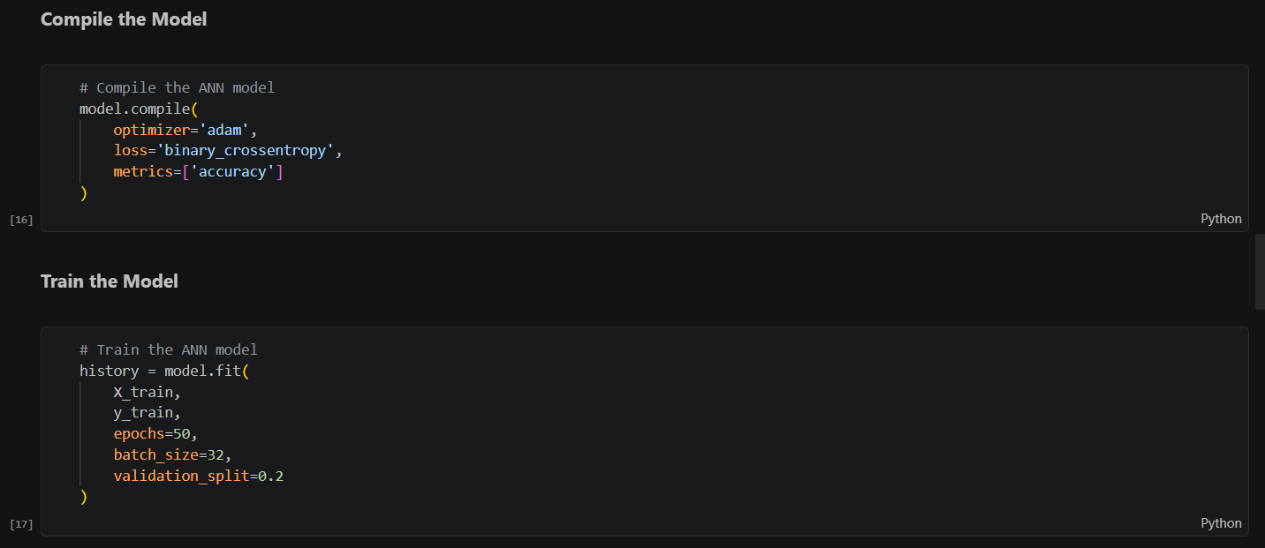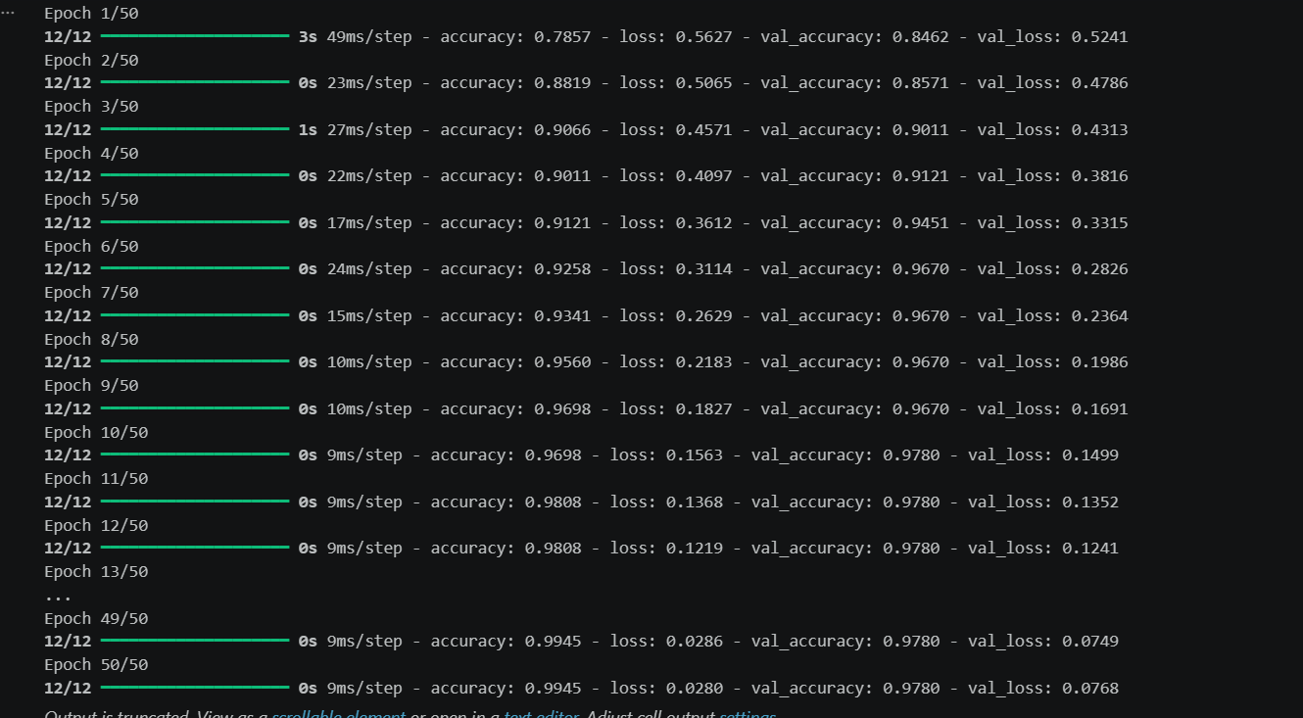

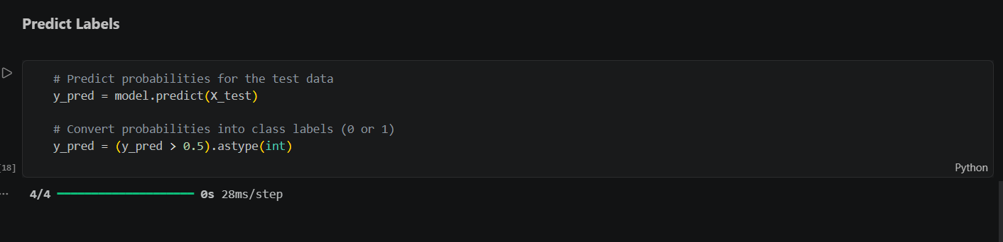

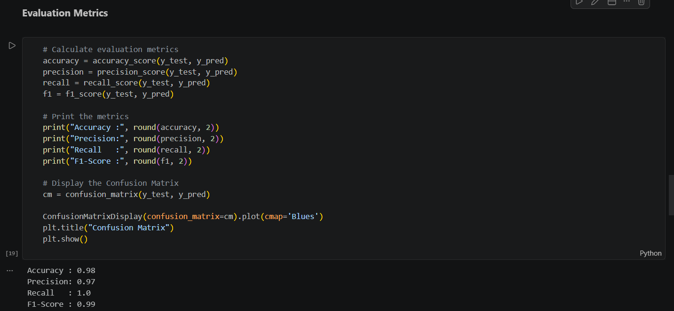

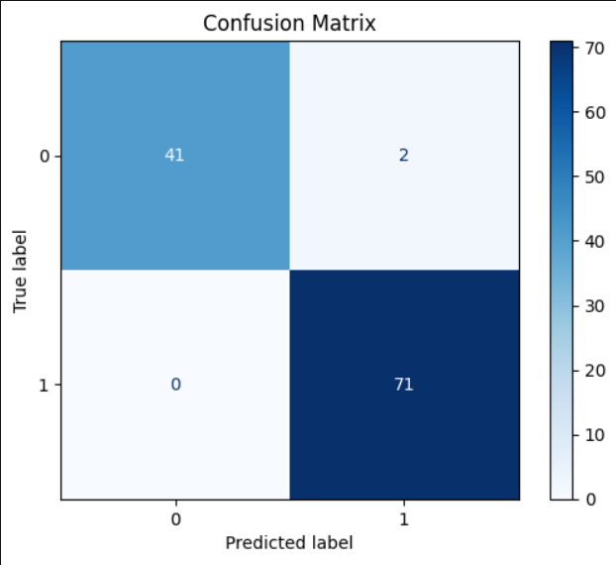

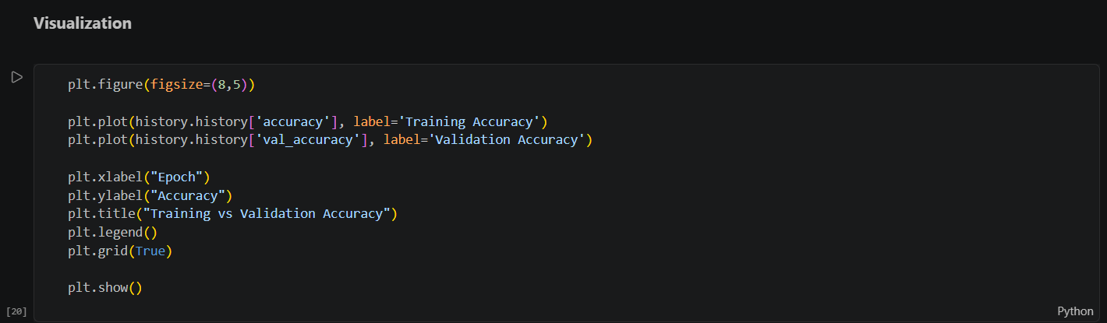
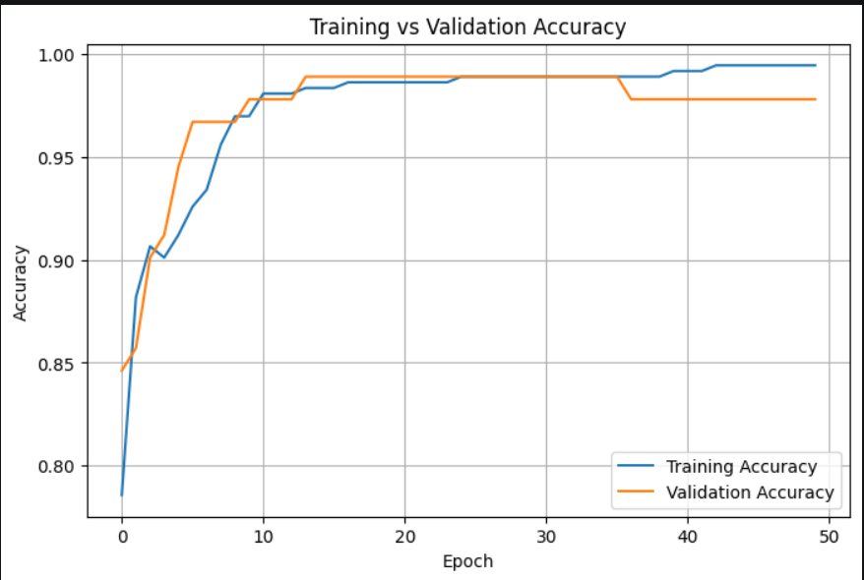

POST-LAB QUESTIONS (PROVIDE BRIEF ANSWERS TO THE FOLLOWING QUESTIONS)

- Why is the Adam optimizer commonly used in ANN training?

The Adam optimizer is commonly used because it updates the network weights efficiently by adapting the learning rate during training. It converges faster, improves learning stability, and performs well on a wide range of deep learning problems.

- Compare Mean Squared Error (MSE) and Mean Absolute Error (MAE). Which metric is more sensitive to outliers?

MSE calculates the average of the squared errors, while MAE calculates the average of the absolute errors. MSE gives more weight to large errors because the errors are squared, making it more sensitive to outliers. MAE treats all errors equally and is less affected by outliers.

- Why is the sigmoid activation function used in binary classification?

The sigmoid activation function is used in binary classification because it converts the output of the neuron into a probability between 0 and 1. This probability can be used to classify the input into one of two classes using a threshold, typically 0.5.

- How does increasing the number of hidden layers affect the performance of an ANN?

Increasing the number of hidden layers enables an ANN to learn more complex patterns, which can improve performance on difficult tasks. However, too many hidden layers increase training time, computational cost, and the risk of overfitting. Therefore, the number of hidden layers should be chosen carefully based on the problem.

- Compare the evaluation metrics used for regression and classification tasks. Why are different metrics required for these problems?

Regression models are evaluated using MSE, MAE, and RMSE because they measure the difference between predicted and actual continuous values. Classification models are evaluated using Accuracy, Precision, Recall, F1-score, and the Confusion Matrix because they measure how correctly the model classifies data into categories. Different metrics are required because regression predicts numerical values, whereas classification predicts discrete class labels.

ASSESSMENT
Description | Max Marks | Marks Awarded
Pre Lab Exercise | 5
In Lab Exercise | 10
Post Lab Exercise | 5
Viva | 10
Total | 30
Faculty Signature

